Onboarding F5 BIG-IP on IBM VPC Cloud (Gen 2)

# Create an object storage bucket and upload your BIG-IP image

1. From your https://cloud.ibm/com dashboard, choose “Create Resource”.A screenshot of a cell phone

   Description automatically generated
2. Under “Storage”, choose the “Object Storage” tile.

1. Create your object storage. You may choose any name for “Service Name” (I chose “USCloudDallas”), choose a resource group (I chose “default”) and associate any tags you want to organize your resources. Press “Create”.

1. Now, create a bucket for this service.

1. Choose “Custom Bucket”.

1. Choose a name for your bucket and choose the region of your choice. Note that I chose the “Standard” storage class. Smart Tier may save money, but I haven’t tested it.

1. After creating the bucket, it’s now time for uploading your BIG-IP image. Choose “Upload” – “Files”.

1. Choose “Select Files” from the “Upload files using Aspera high-speed transfer” window. A dialog will open on your PC for you to choose the qcow2 image you downloaded from downloads.f5.com.

1. Click “Allow” from the “Confirm – IBM Aspera Connect” window. The image will now upload. Depending on your internet connection this could take a while (it took about 60 minutes for me to upload). Once completed, you will see something like this:

# Create a VPC Instance (you may skip this if you already have one)

1. From your https://cloud.ibm/com dashboard, choose “Create Resource”.

1. Under “VPC Infrastructure”, choose “Virtual Private Cloud”:

1. You will now create your VPC. Make sure the screen says “Gen 2” compute. It should default to Gen 2 and not Gen 1, but make sure it looks like this:

1. Name your VPC whatever you want. Note that you MUST use only lowercase letters and hyphens. That’s it. So, “VPC-test” will not work, you must use a name like “vpc-test”. Note also “vpc_test” or “vpc test” will not work. Hyphens only!

1. Scroll down to continue to configure your VPC, including creation of your first subnet:

1. Continue to scroll down to see the IP address space created on your subnet. Press the “Create virtual private cloud” button to start the process.

1. Within a second or two the VPC Gen 2 menu should appear along with your created VPC:

# Create a Virtual Server Instance (BIG-IP)

1. On the VPC Gen 2 menu, click on “Virtual Server Instances”

1. Click on “New Instance”

1. Choose the name for your instance (this is NOT the BIG-IP hostname) and make sure you deploy into the correct VPC (if you have more than one).

1. Continue to scroll down. Make sure you’re choosing the correct data center. For image, choose “Custom image”. When you do, choose the BIG-IP image you uploaded to your object storage. I only had one image uploaded as you can see here:

1. Now, choose what compute profile you wish to use. First, click “All profiles” so you don’t only see the most popular ones.

1. Once “All profiles” is targeted, click the “Compute” tab. Your compute profile will depend on the exact BIG-IP license you wish to deploy. Please see [here](https://clouddocs.f5.com/cloud/public/v1/kvm/kvm_setup.html) for CPU, RAM and disk size recommendations. For simplicity, we recommend choosing from the ones highlighted, again, depending on which license you wish to deploy.

1. Now choose an ssh key you created for your account and then click “Create virtual server instance”.

1. You will now see your virtual instance starting

1. Once the instance has been created, we now need to assign a floating IP so we can communicate with it. Click on your instance after it’s powered-up and scroll down to your network interfaces. Click “Reserve +” to create the floating IP.

1. You will now have your new floating IP:

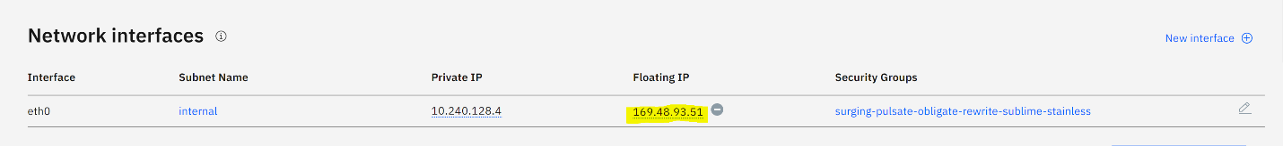

1. Click on your security group so we can open up some ports to be able to login:



1. Click on “new rule”:

1. Let’s open up port 8443 (since we’re single NIC) to be able to open the GUI:

1. Click “Save”.
2. Test connectivity to your instance. Open up a new tab in your browser and choose the floating IP of your instance. In my case, <https://169.48.93.51:8443>

